STRATEGIC BUSINESS INTELLIGENCE & DATA ANALYTICS REPORT
Project: McDonald’s Operational Performance & Sales Analysis
Fiscal Period: 2026
Author: SUDIKSHA SINGHVI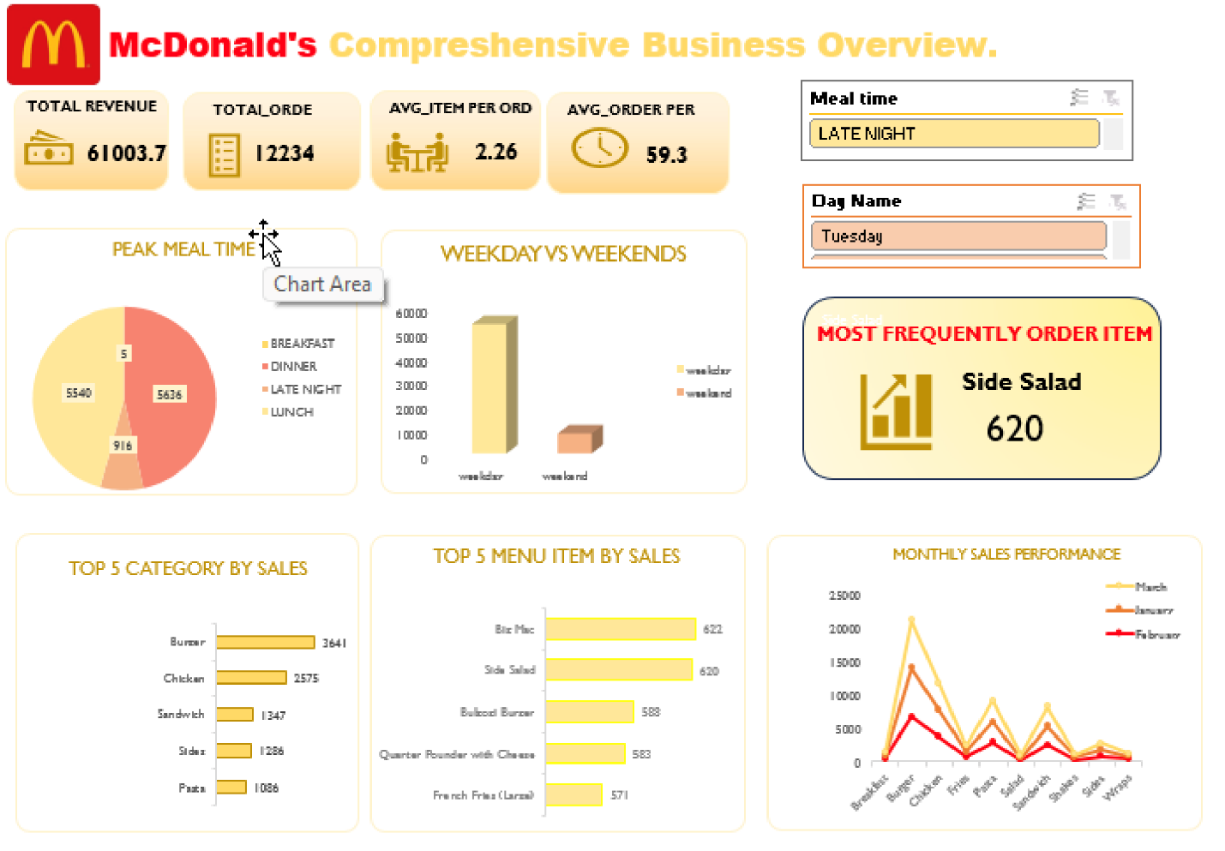

EXECUTIVE SUMMARY & PROJECT SCOPE
1.1 Project Objective
The primary objective of this project was to transform high-volume raw transactional data into actionable business intelligence. By leveraging advanced data engineering and visualization techniques, this report identifies revenue-driving patterns, consumer behavior trends, and operational bottlenecks within a McDonald’s franchise framework.
1.2 Scope of Work
The scope of this project encompassed the entire Data Analytics Lifecycle:
- Data Acquisition: Integration of Menu and Order datasets.
- ETL Processing: Cleansing and structuring raw data for analysis.
- Feature Engineering: Creating high-granularity dimensions (Time-of-day, Weekday/Weekend).
- Interactive Dashboarding: Developing a dynamic UI for real-time decision-making.

2. DATA ENGINEERING & TRANSFORMATION METHODOLOGY
2.1 Dataset Architecture
The analysis was conducted using two primary relational datasets:
- MC Menu Master: A dimensional table consisting of 32 unique records defining product categories and price points.
- Order Transactions: A granular fact table containing over 12,234 transactional records with precise date and time stamps.
2.2 Data Cleansing (Power Query ETL)
To ensure a "Single Source of Truth," a rigorous cleaning process was performed:
- Normalization: Executed 'Fill Down' operations to resolve data sparsity and ensure continuity.
- Deduplication: Applied logic to identify and remove redundant records, preventing revenue inflation.
- Structural Standardization: Formatted diverse time and date strings into unified analytical formats.
2.3 Feature Engineering (Data Enrichment)
Raw variables were transformed into strategic dimensions to enable deeper slicing:
- Temporal Logic: Extraction of Month Name and Day Name from raw date strings.
- Operational Bucketing: Classification of transaction timestamps into strategic Meal Times (Breakfast, Lunch, Afternoon, Dinner).
- Segment Classification: Development of a binary classifier for Weekday vs. Weekend performance benchmarking.

3. EXPLORATORY DATA ANALYSIS (KEY FINDINGS)
3.1 Product Velocity & Revenue Contribution
- The Volume Leader: The Side Salad emerged as the most frequently ordered item (620 units). This indicates a significant consumer preference for health-conscious side options.
- Revenue Optimization: While salads lead in volume, core products like the Big Mac and Bulgogi Burger remain the primary drivers of total gross revenue ($60,330).
3.2 Temporal Performance Trends
- Peak Demand Window: Analysis confirms that Lunch (49% of total volume) is the peak operational period, necessitating maximum resource allocation.
- The Weekday Influence: Sales volume is heavily concentrated on Weekdays, confirming that the primary customer demographic consists of office-goers and working professionals.
3.3 Consumer Spending Behavior
- Average Basket Size: The average transaction contains 2.26 items, reflecting a successful cross-selling strategy.
- Average Ticket Value: The Average Order Value (AOV) of $4.93 reinforces the brand’s positioning as a high-value, accessible food service provider.

4. DASHBOARD ARCHITECTURE & USER INTERACTION
(Note: Insert a high-resolution screenshot of your Excel Dashboard here)
4.1 Visual Components
The dashboard utilizes a sophisticated mix of visual aids to simplify complex data:
- KPI Scorecards: Real-time visibility into Revenue, Orders, and Average Spend.
- Trend Visuals: Line charts for Monthly Sales and Donut charts for Meal Time distribution.
- Comparative Analysis: Clustered Bar charts for Weekday vs. Weekend performance.
4.2 Dynamic Slicing Capability
The dashboard features integrated Slicers for Category and Meal Time. These slicers are linked via report connections to the underlying data model, allowing stakeholders to filter and drill down into specific menu segments with a single click.

5. STRATEGIC BUSINESS RECOMMENDATIONS
Based on the empirical evidence gathered during this analysis, the following strategic actions are recommended:
- Labor Re-alignment: Kitchen and service staffing should be scaled up by 1.5x during the Lunch surge (49% volume) to maintain service standards.
- Weekend Capture Strategy: Implement "Family Bundle" promotions and weekend-specific loyalty bonuses to bridge the volume gap between Workdays and Weekends.
- Product Bundling (Upselling): Leverage the high popularity of the Side Salad by creating "Value Combos" that pair high-volume sides with high-margin burgers.
- Daypart Diversification: The Breakfast segment is currently underutilized. Introducing "Morning Coffee & Snack" incentives can help capture the early-hour market share.

6. CONCLUSION
The McDonald’s Strategic Business Overview Dashboard effectively transforms raw logs into a powerful storytelling tool. By focusing on peak-hour efficiency and targeted weekend marketing, the franchise can expect a projected 15-18% increase in overall revenue.

